1. Draw the magnetic field that exists between [3]  
     
   1. Two North poles
   2. Two South poles
   3. A north and a south pole
2. Sketch the magnetic field in the plane shown for each case: [4]

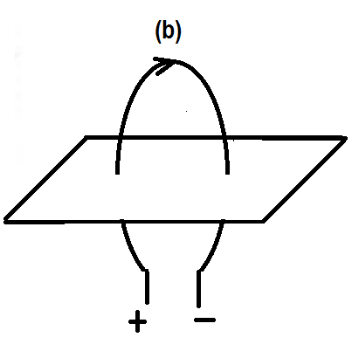

***I***

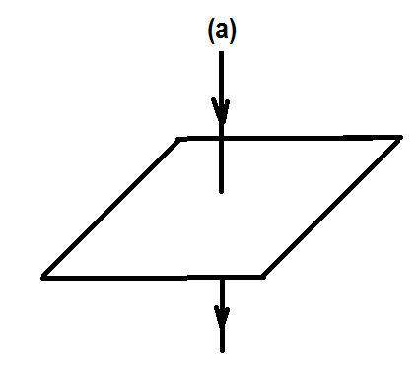

***I***

1. A compass needle is placed due west of a vertical wire. A current flows through the wire. What is the direction of the current if:
   1. The compass needle points south ______________________ [1]  
        
      and
   2. The compass needle points north ______________________ [1]
2. What is the direction of the magnetic field at :

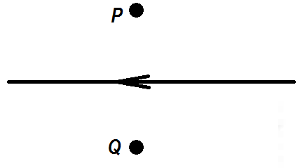

***I***

* 1. Point P _________________________ [1]  
       
     and
  2. Point Q __________________________ [1]

1. Draw the magnetic field around the solenoid shown. Indicate the poles of the magnet formed. [2]

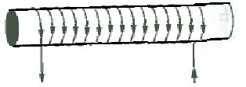

***I***

***I***

1. Two long parallel wires carry equal currents in opposite directions. The magnitude of the force between the wires due to the currents is F. the separation between the wires is now doubled. The force between the wires due to the currents is now which of the following. [1]

$\frac{F}{2}and attractive$

$\frac{F}{2}and repulsive$

$\frac{F}{4}and attractive$

$\frac{F}{4}and repulsive$

Briefly explain your choice. [2]

1. 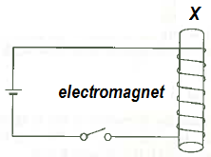The figure shows a solenoid wound around a core of soft iron to form an electromagnet.
   1. When will the electromagnet attract magnetic materials?

[1]

* 1. How can the strength of the electromagnet be increased?

[2]

* 1. Show the direction of current flow when the switch is on. Will the end marked X become a north pole or a south pole? Briefly explain.

1. 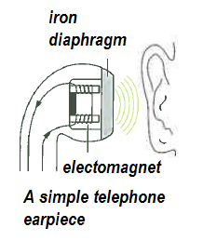The diagram shows a simple telephone earpiece or receiver. Explain how it works. [3]

1. 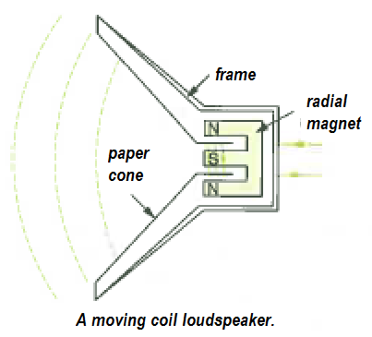The diagram shows a different simple telephone earpiece or receiver. Explain how it works. [3]

1. 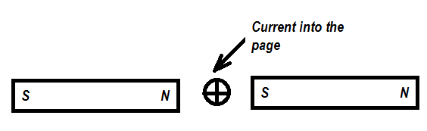The diagram shows a conductor carrying a current in a direction “into the page”.

* 1. What is the direction of the force on the conductor?____________________ [1]
  2. If the direction of the current is reversed, what is the direction of the force on the conductor? __________________________ [1]
  3. How could the strength of the force on the conductor be increased using the same length of conductor and the same magnets? [2]  
     ________________________________________________________________________________________________________________________________
  4. How could the strength of the force on the conductor be made zero using the same length of conductor and the same magnets? [1]  
     ________________________________________________________________________________________________________________________________

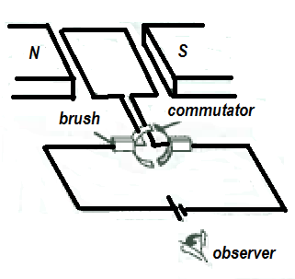

1. The diagram shows a simple DC motor.
   1. What causes the coil in a DC motor to turn? How can the coil be made to turn faster? [3]

* 1. What is the direction of rotation of the motor as seen by the observer? [1]

* 1. What will happen to the direction of rotation of the coil if both the poles of the magnets and the polarities of the battery are reversed at the same time? [1]

* 1. Describe the motion of the coils if the two ends of coil are connected directly to a battery without using the commutator and the brush. [2]

1. Which one of the following action(s) does not cause an induced emf to be set up in a coil of wire? Briefly explain your choice(s). [3]  
   1. Pushing a magnet into the stationary coil.
   2. Moving the coil over a stationary magnet.
   3. Having a steady current flow through the coil.
   4. Withdrawing a magnet from inside the coil.
   5. Moving the coil and magnet at the same velocity.

1. 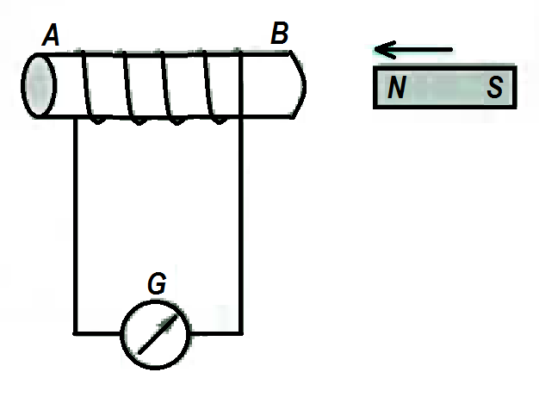A magnet is being pushed into a coil of wire which is connected to a galvanometer. Which of the following statements is/are correct? Briefly explain your choice(s). [3]  
   1. The induced current will flow from A to B through the coil.
   2. The induced current will flow from B to A through the coil.
   3. No induced current will flow.
   4. End B will become a north pole.

14. The magnetic field strength inside a solenoid depends on the current through the solenoid. It also depends on factors such as the number of turns of wire in the solenoid, the length of the solenoid and the permeability of the medium inside the solenoid. The relationship between these various factors is:



where:

***B*** is the magnetic field strength in the centre of the solenoid (T)

***μ*** is the permeability of the medium inside the solenoid

***N*** is the number of turns of the solenoid

***I*** is the current in the solenoid (A)

***L*** is the length of the solenoid (m)

Some students devised an experiment to determine the permeability of air. They used a current balance apparatus to measure the magnetic field inside a solenoid for several different values of current. Their solenoid was 20.0 cm long and consists of 800 turns of wire.

Their results have been plotted on the graph on the next page:



a) Draw in the line of best fit on the graph. [2]

b) Would you expect the line to pass through the origin? Explain. [2]

c) What does the gradient of your graph represent? [2]

d) Use your graph to determine a value for ***μ*** (include the units for***μ***) [4]

Answer: _____________________

e) What effect would including a soft iron rod down the centre of the solenoid have on their results? Explain why. [3]

END OF PRACTICAL TEST